|  |
| --- |
|  |
|  |

|  |  |  |  |  |  |
| --- | --- | --- | --- | --- | --- |
| REVISION HISTORY | | | | | |
| Ver. | Description of Change | Author | Date | Approved | |
| Name | Effective Date |
| 1.0 | Initial status | Hanna Takushevich | 29-NOV-2017 |  |  |

Contents

1. Create Packages for Reload Dimension from SA_* 3

2. Task Results 3

# Create packages to load dimensions from source to staging (3NF) layer

The Main Task is to create independent packages to load dimensions according to your DWH solution concept that was developed on Module 6 Introduction to DWH.

Required points:

* Create all required dim objects on ST Layer (T_...).
* Grant all required privileges to ST_CL (Cleansing Layer).
* Create packages to load dim data (one package = one dimension) on ST_CL.
* Use Explicit Cursor (One or more procedures).

Процедура для заполнения cls таблицы с сабрегионами:

PROCEDURE load_to_cls

IS

subr_code wrk_subregions.subregion_code%TYPE;

subr_name wrk_subregions.subregion_name%TYPE;

subr_country_key wrk_subregions.subregion_country_key%TYPE;

CURSOR c1

IS

SELECT * FROM wrk_subregions;

BEGIN

EXECUTE IMMEDIATE 'truncate table cls_subregions';

OPEN c1;

LOOP

FETCH c1 INTO subr_code, subr_name, subr_country_key;

EXIT

WHEN c1%NOTFOUND;

INSERT INTO cls_subregions VALUES

(subr_code, subr_name, subr_country_key

);

END LOOP;

CLOSE c1;

COMMIT;

EXCEPTION

WHEN OTHERS THEN

RAISE;

END load_to_cls;

* Use Implicit Cursor (One or more procedures).

Процедура для заполнения cls таблицы c авиалиниями:

PROCEDURE load_to_cls

IS

BEGIN

EXECUTE IMMEDIATE 'truncate table cls_airlines';

INSERT INTO cls_airlines

SELECT airline_name,

SUBSTR(icao_iata_codes, **1**, **3**),

SUBSTR(icao_iata_codes, **7**, **2**),

airline_country

FROM wrk_airlines

WHERE airline_country IS NOT NULL

AND SUBSTR(icao_iata_codes, **1**, **3**) IS NOT NULL;

COMMIT;

EXCEPTION

WHEN OTHERS THEN

RAISE;

END load_to_cls;

* Use Merge (One or more procedures).

Загрузка данных в 3nf таблицу с городами.

PROCEDURE load_to_3nf

IS

BEGIN

--EXECUTE IMMEDIATE 'truncate table cls_regions';

MERGE INTO ce_cities ct USING

( SELECT city_name, cc_fips FROM cls_cities

MINUS

SELECT city_name, cc_fips FROM ce_cities

) cls ON ( cls.city_name = ct.city_name )

WHEN MATCHED THEN

UPDATE SET ct.cc_fips = cls.cc_fips WHEN NOT MATCHED THEN

INSERT

(

city_id,

country_id,

cc_fips,

city_name

)

VALUES

(

city_seq.nextval ,

(select country_id from ce_countries where ce_countries.cc_fips=cls.cc_fips),

cls.cc_fips,

cls.city_name

);

COMMIT;

EXCEPTION

WHEN OTHERS THEN

RAISE;

END load_to_3nf;

# Task Results

Create required objects:

* Prepare document with description of your load and screenshot of data in the Dimension Tables.
* Test Procedure for Repeatable execution (it should produce same consistent results each time on a same source data).

select * from ce_aircrafts

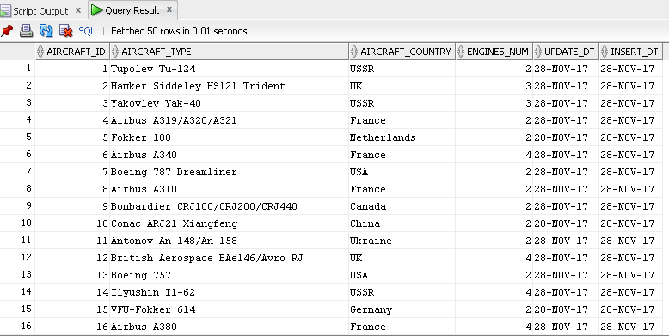

select * from ce_airlines

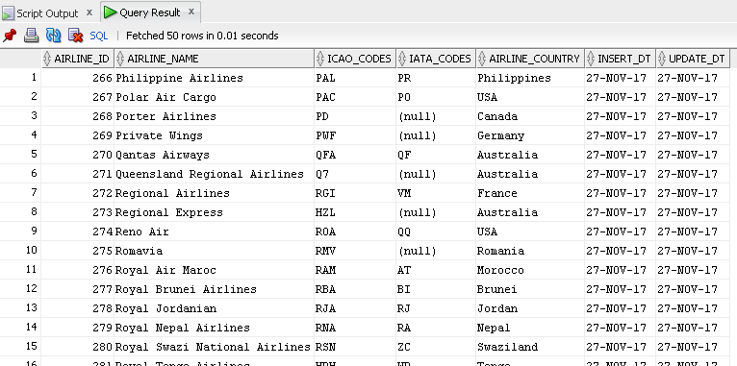

select * from ce_airports

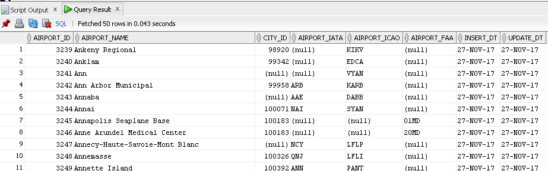

select * from ce_cities

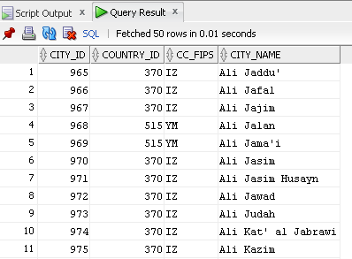

select * from ce_countries

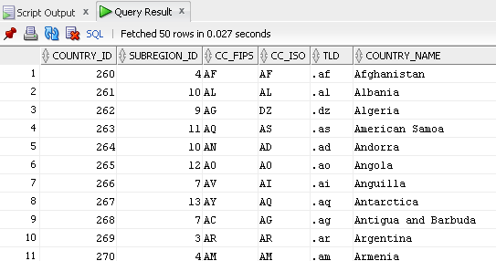

select * from ce_flights

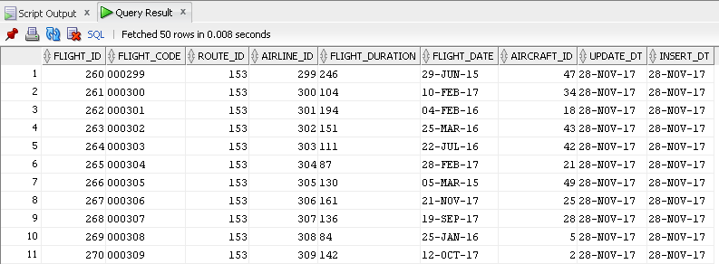

select * from ce_passengers

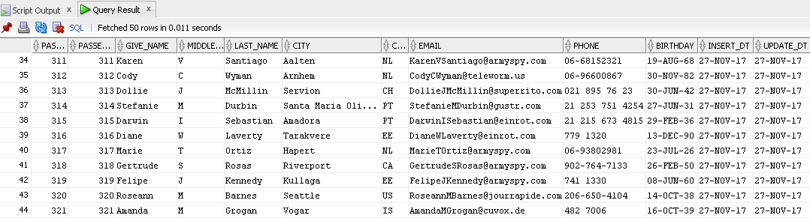

select * from ce_regions

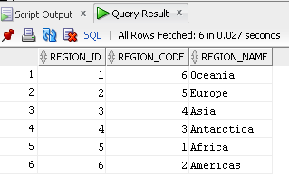

select * from ce_routes

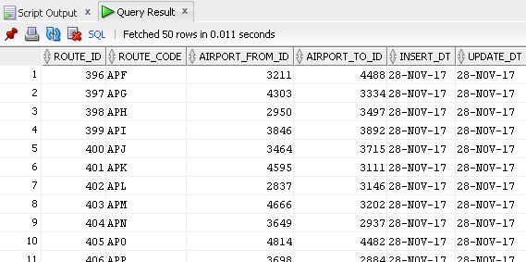

select * from ce_subregions

